1. Configure 2 slave machines in jenkins master.  
   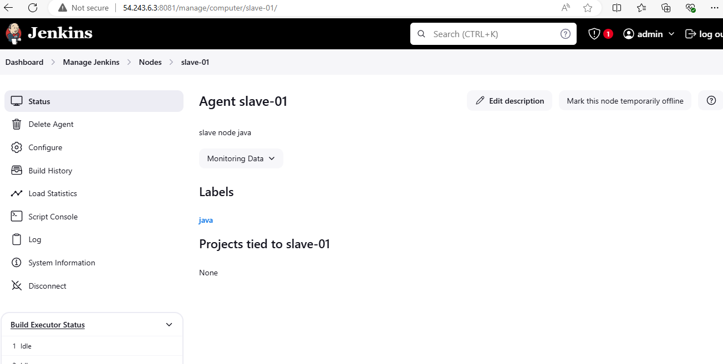  
   While executing the second slave use the use existing (slave-01) just change the public ip and the location of workspace is different then use that location only.

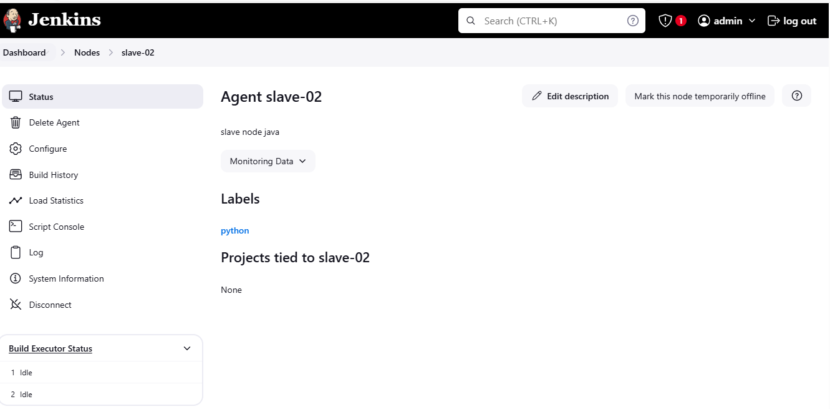

1. Configure webhooks to jenkins job.  
   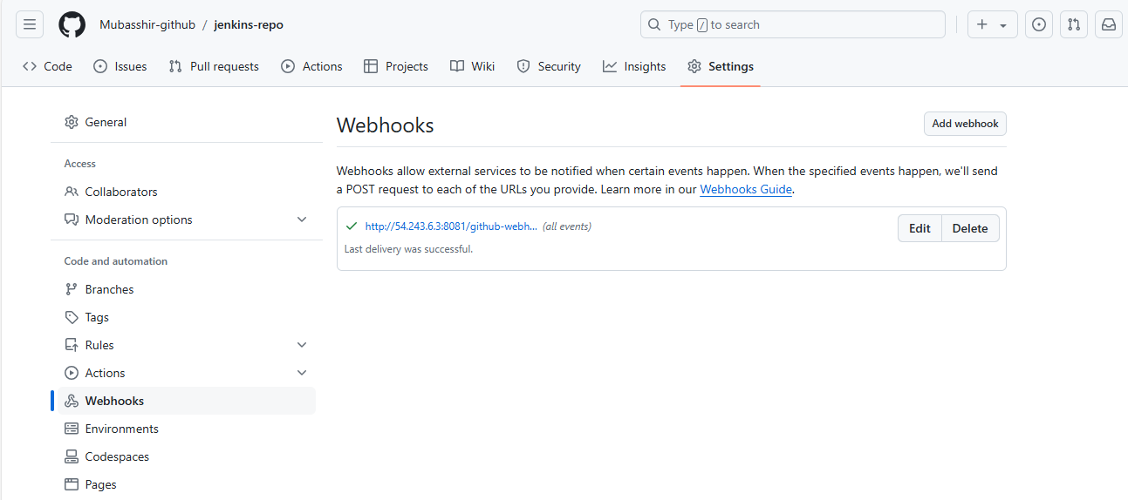

Go inside the job and select the option (GitHub hook trigger for GITScm polling)

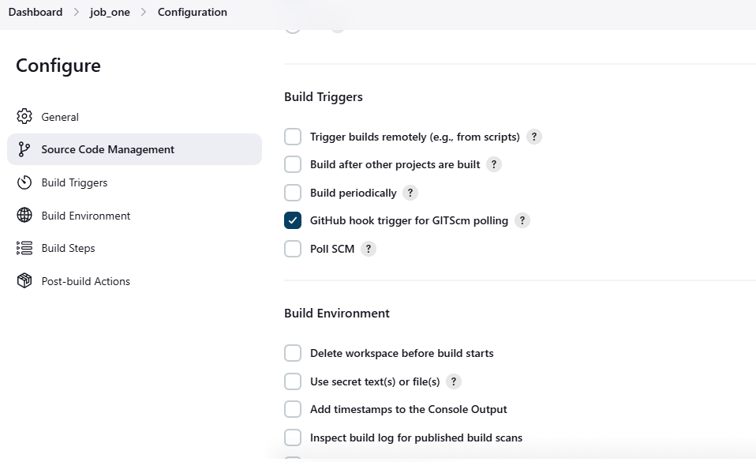

As I have configured the job in slave-01, I need to configure the Slave label inside the job

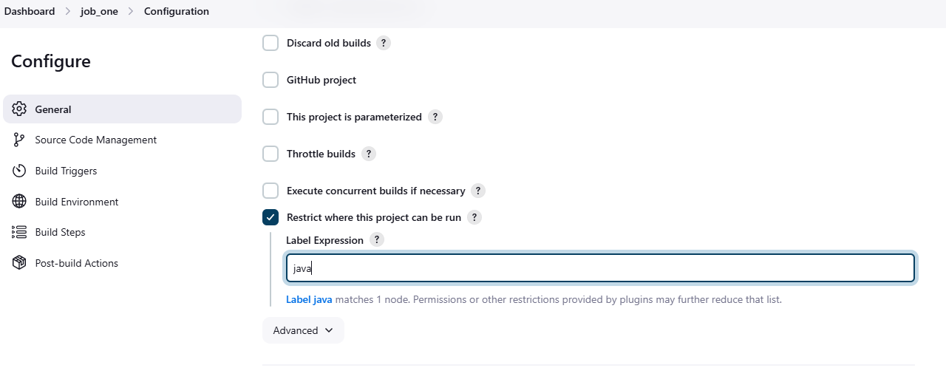Also make sure you are using the same repo configure in the github. If master then use master or if there any other then use that here in configurations only.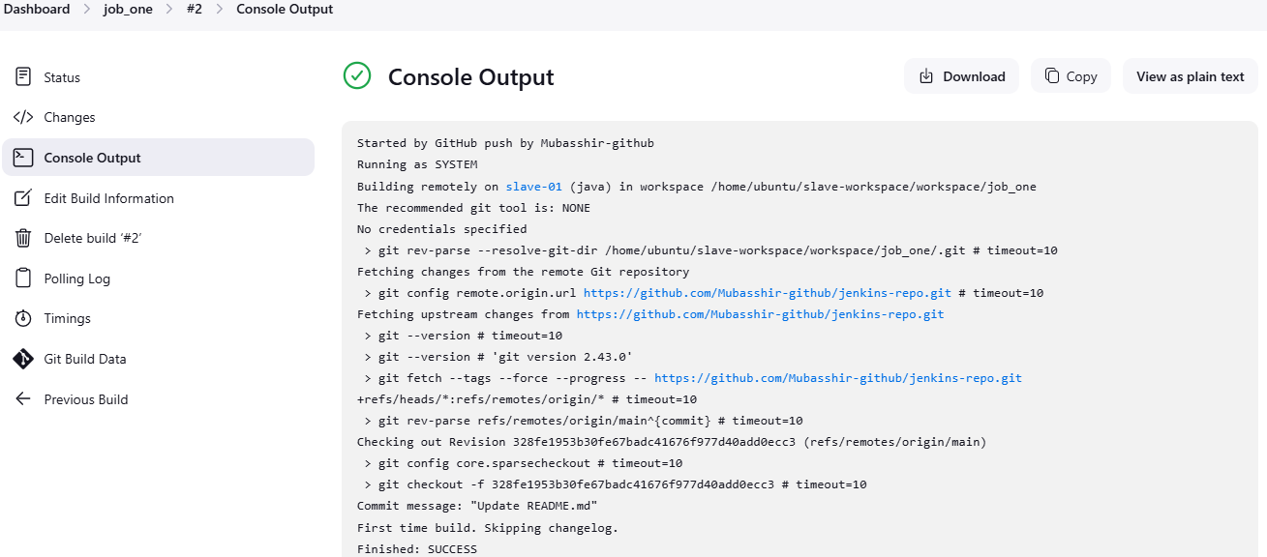

1. Configure poll scm and build periodical options in jenkins job.

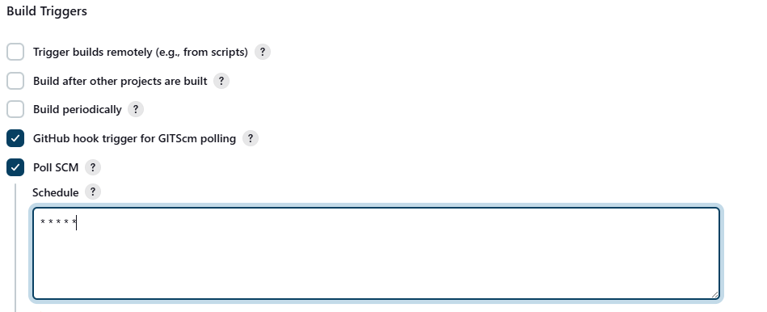  
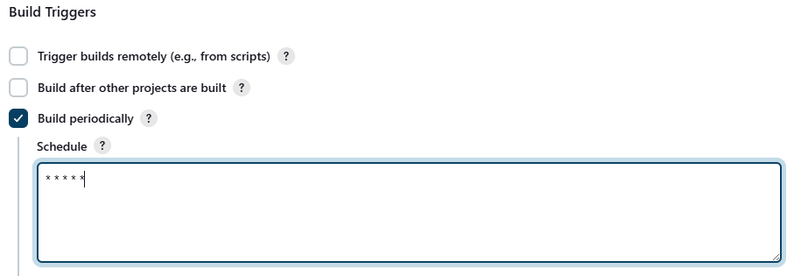

1. Take backup of Jenkins server by using bash script.

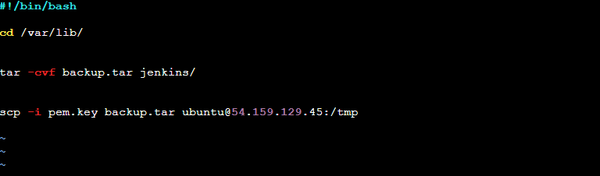 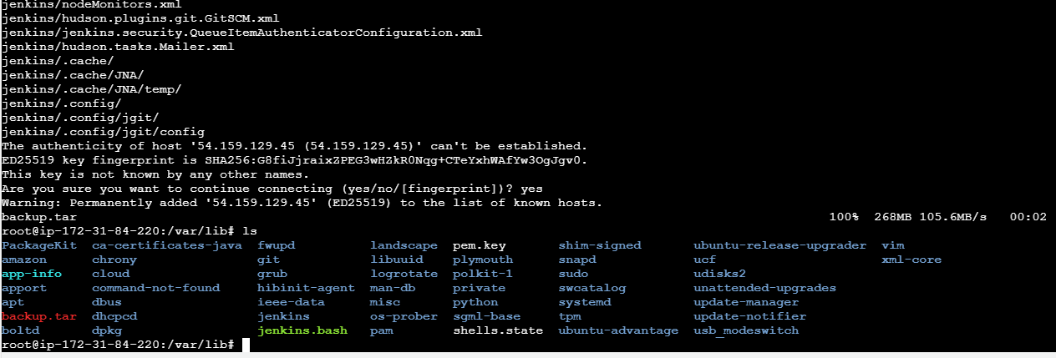

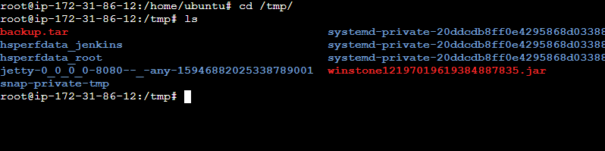

Configured the backup successfully

1. Take backup of Jenkins using rethin backup plugin.  
   downloaded the plug in

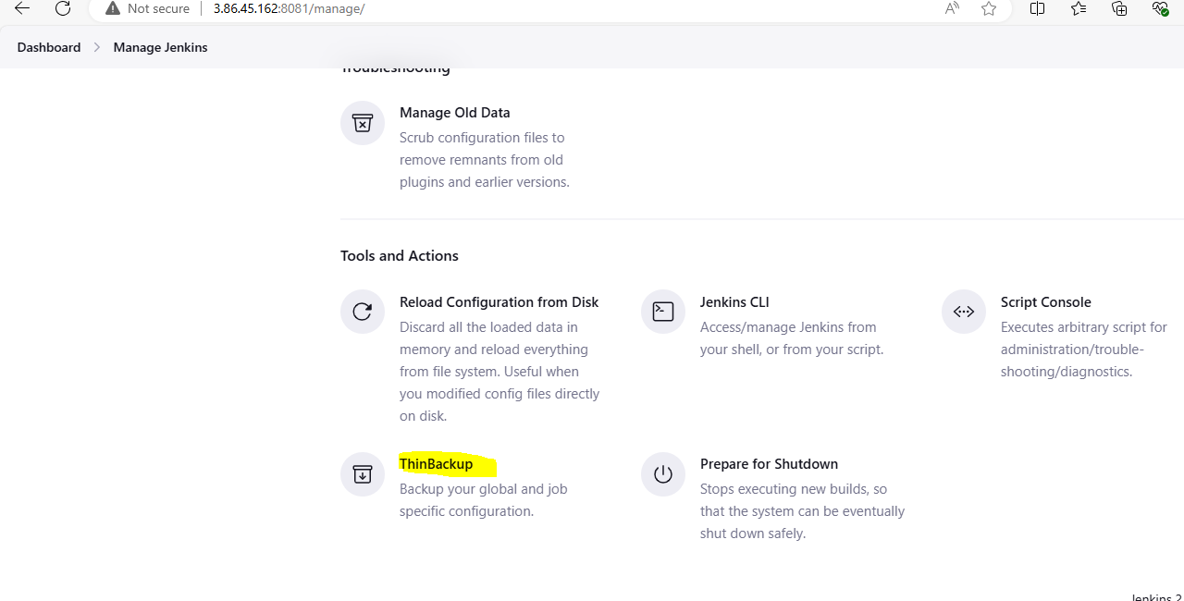

1. Setup a new Jenkins server and dump the backup taken in task4.



